**Name**: Oriens Lacunosum-Moleculare (OLM) (Ali and Thomson, 1998) – Hippocampal CA3 Interneuron

**Biological Data**

**Passive properties**: Vrest = -65 mV to -85 mV Tau = 12·8 ± 1·5 ms Rin = 70 ± 13·72 MΩ (Ali and Thomson, 1998)

________________________________________________________________________________________

**Passive properties of model OLM Interneuron:**

|  |
| --- |
| **1. V_rest = -68.5 mV**  **2. Calculation of time constant:**  Start inject: 300ms / -68.5mV Final Value: ~ -74.94mV Difference: -6.44 | 63.2% = -4.07 | -68.5 - 4.07 = - 70.4352 Time at - 72.57: 113.7ms τ = 310.55-300  τ = 10.55 ms  **τ = .01055 s**  **3. Input Resistance**  ΔV/ΔI = ( -68.5 – (-74.94) )/( 0 – (-100) )  = 6.44mV / 60pA  **R_in =64.417 MΩ** |

**Comparison of F-I curves (Actual: Green, Model: Black)**:

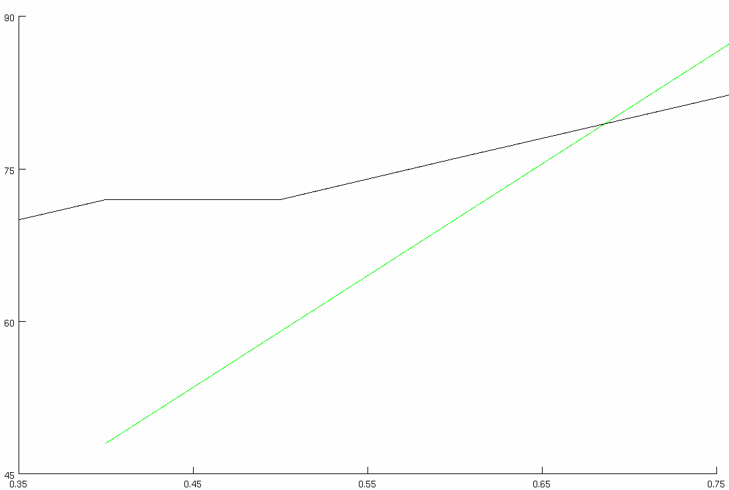

**Match with reported current injection responses (provide all):**

|  |  |  |
| --- | --- | --- |
| **400** |  |  |
| **pA** | **Real** | **Cell Model** |

|  |  |  |
| --- | --- | --- |
| **800** |  |  |
| **pA** | **Real** | **Cell Model** |

**Table 2-1. GATING PARAMETERS OF ION CHANNELS**

|  |  |  |  |  |  |
| --- | --- | --- | --- | --- | --- |
| **Current Type** | **Gating Variable** | **α** | **β** |  | **τx (ms)** |
| *INa* | *p=3* |  |  |  |  |
| *q=1* |  |  |  |  |
| *IKdr* | *p=1* |  |  |  |  |
| *IKM* | *p=2* |  |  |  |  |
| *INap* | *p=1* | ― | ― |  |  |

**Table S2. Parameters of single cell models**

|  |  |  |
| --- | --- | --- |
|  | OLM interneuron | |
|  | soma | dendrites |
| Cm (µF/cm2) | 1.5 | 1.5 |
| Ra (Ωcm) | 150 * 22.5 | 150 |
| Conductance (mho/cm2)  gNabar  gKdrbar  gLeak  gNapbar  gImbar | 0.02  0.18  1.3e-4  0.0017  0.005 | 0.02  0.18  1.3e-4  0.0017  0.005 |

**References**

Ali AB, Thomson AM. 1998. Facilitating pyramid to horizontal oriens-alveus interneurone inputs: Dual intracellular recordings in slices of rat hippocampus. J Physiol 507:185–199.